Network Configuration – Configure node1 with above details hostname,ip, dns
ip address = 172.24.2.10
gateway = 172.24.2.72
netmask = 255.255.255.0
DNS = 172.24.2.72
hostname = node1.net2.example.com

VM – Edit – virtal network editor – change setting – yes – Remove all network – Add network – select a network add : VMnet 10 – ok – apply – ok.

VM – settings – Network adapter2 – custom : VMnet10 – ok.

with nmcli tool
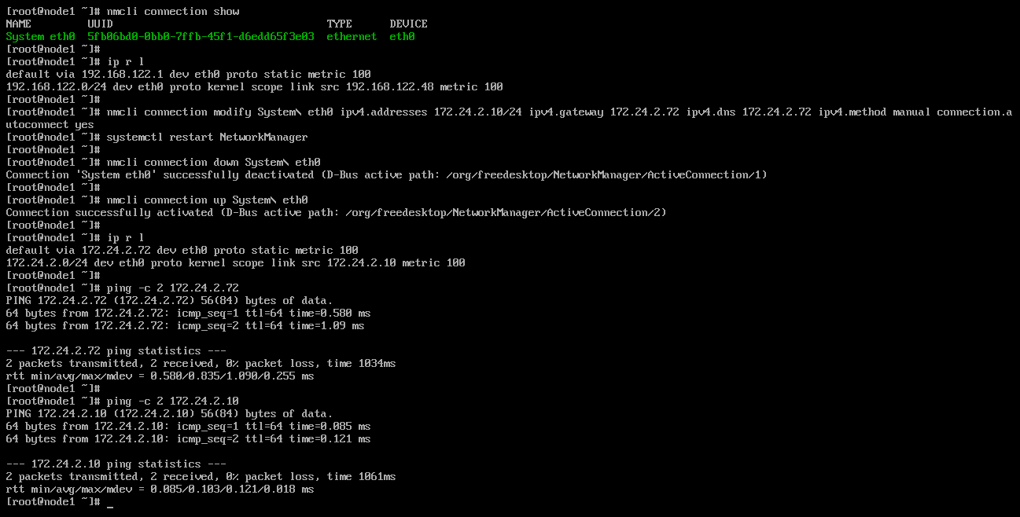
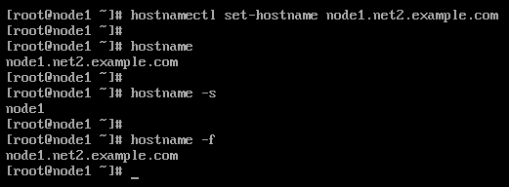
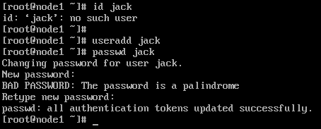

Now, we are taking SSH remote access from workstation to Node1.
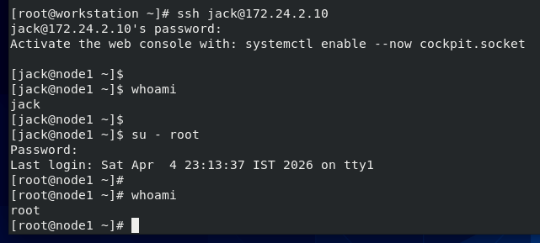

with nmtui tool
